**Assignment Chapter 7**

**Question 1:**

Write a SELECT statement that returns the same result set as this SELECT statement, but don’t use a join. Instead, use a subquery in a WHERE clause that uses the IN keyword.

SELECT DISTINCT category_name

FROM categories c

JOIN products p

ON c.category_id = p.category_id

ORDER BY category_name

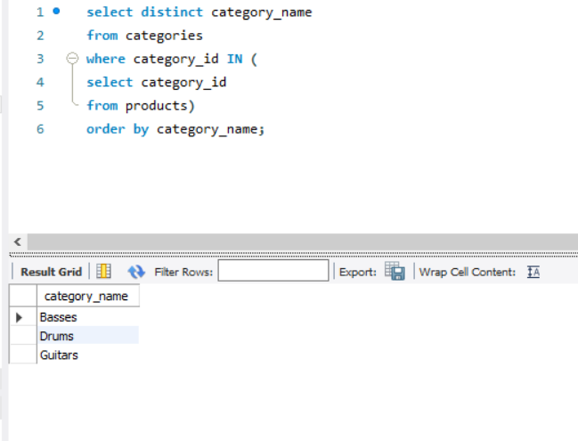

**Question 2:**

Write a SELECT statement that answers this question: Which products have a list price that’s greater than the average list price for all products? Return the product_name and list_price columns for each product. Sort the result set by the list_price column in descending sequence.

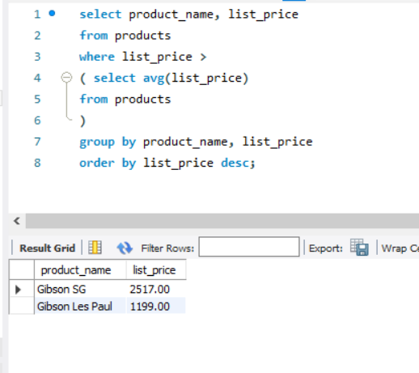

**Question 3:**

Write a SELECT statement that returns the category_name column from the Categories table. Return one row for each category that has never been assigned to any product in the Products table. To do that, use a subquery introduced with the NOT EXISTS operator.

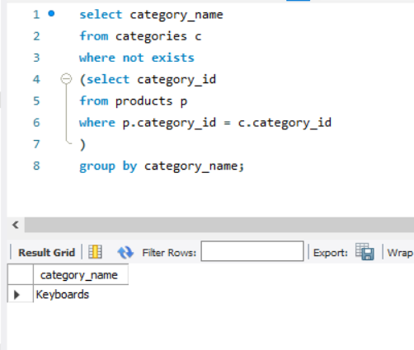

**Question 4:**

Write a SELECT statement that returns three columns: email_address, order_id, and the order total for each customer. To do this, you can group the result set by the email_address and order_id columns. In addition, you must calculate the order total from the columns in the Order_Items table.

Write a second SELECT statement that uses the first SELECT statement in its FROM clause. The main query should return two columns: the customer’s email address and the largest order for that customer. To do this, you can group the result set by the email_address. Sort the result set by the largest order in descending sequence.

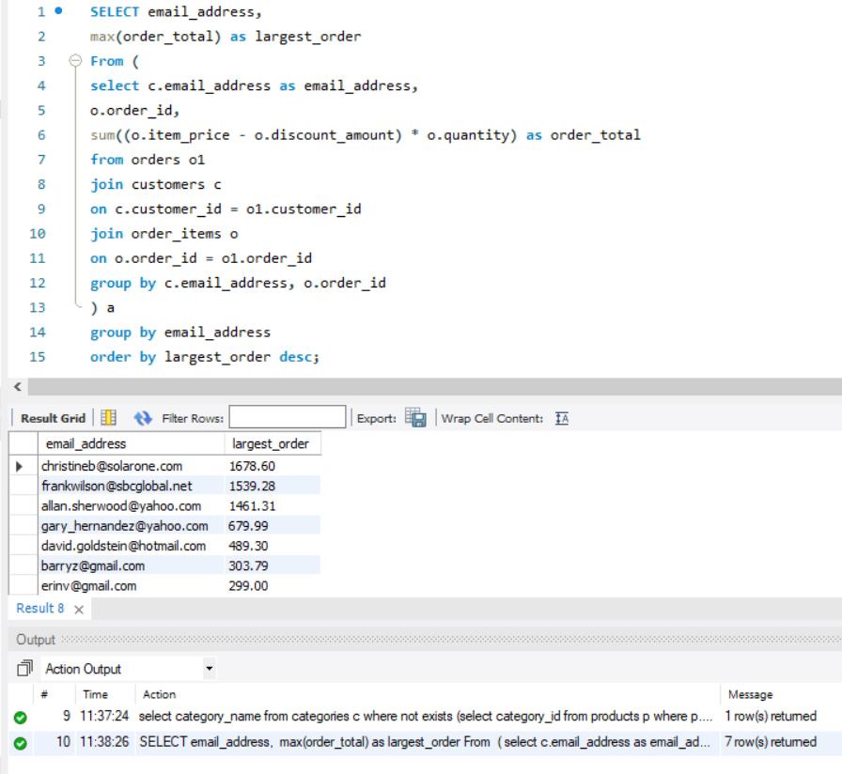

**Question 5:**

Write a SELECT statement that returns the name and discount percent of each product that has a unique discount percent. In other words, don’t include products that have the same discount percent as another product. Sort the result set by the product_name column.

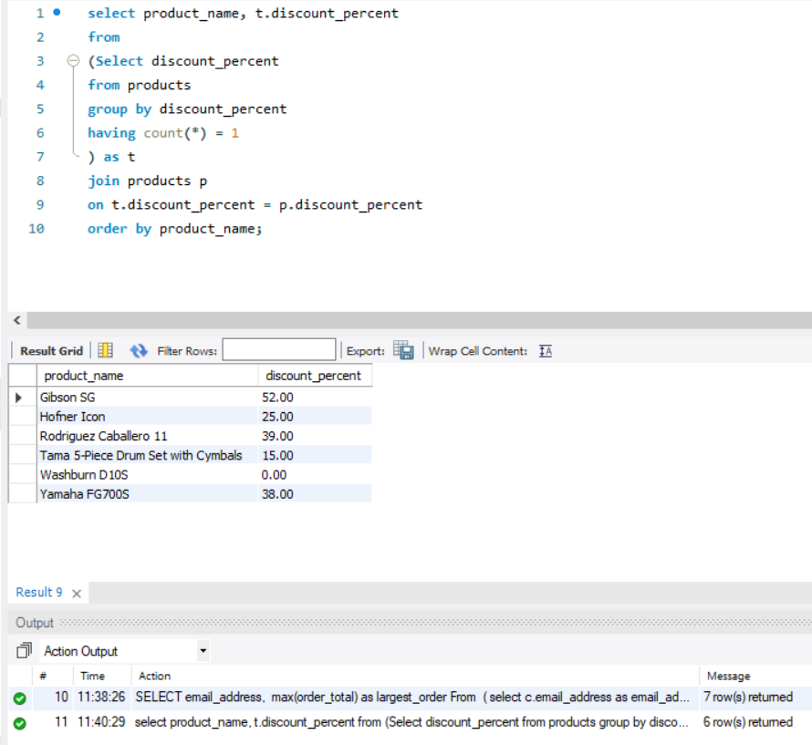

**Question 6:**

Use a correlated subquery to return one row per customer, representing the customer’s oldest order (the one with the earliest date). Each row should include these three columns: email_address, order_id, and order_date. Sort the result set by the order_date and order_id columns.

